THANK YOU!!
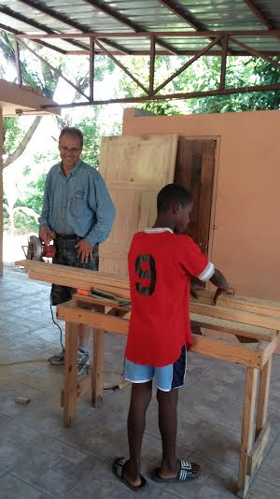
Bryan building a wall at Miss Sue’s new place. CJ’s dad was killed in the Earthquake and his mom died in childbirth. He followed Bry around the whole time.

Dear Friend,
“Thank you” doesn’t communicate our gratefulness to you
enough. We are beyond thankful for your prayers, financial
support, supplies, supply sign-up and even “massages for
Haiti.” Our trip was God orchestrated and amazing. We were
overjoyed, inspired and saddened in Haiti.

The joy came with being on the Christianville property,
interacting with the staff and teams from around the country
and seeing true love in action—Miss Sue’s orphanage. It was
better than we expected. Her kids are loved, nourished,
nurtured and educated (she homeschools most of them
and they get amazing schooling).
We were inspired by the dedication of the staff who gives
unselfishly on a long-term basis to provide food for the
children of Haiti through the Christianville farm. It provides
one hot meal a day to 1200 school children and orphanages all around. We were also inspired by a culinary school, Tuberculosis lab, agriculture school and the microloan chicken coups. The most inspiring people were a young pastor and his wife who decided to leave the comforts of the states and run a struggling orphanage a few miles from Christianville. Going on a short-term trip is nice, but the people who are there in the trenches day in and day out are true heroes.
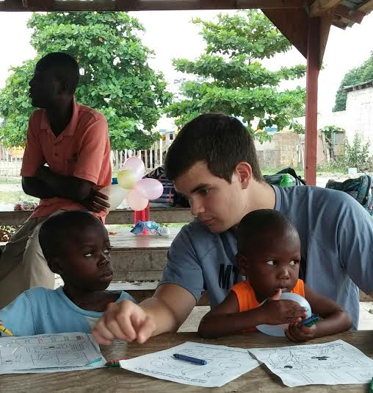

Orphanage at Leogone. Most of the kids were malnourished. Special thanks to David’s Natural Market. 500 supplement packs donated!
We used every one of them.
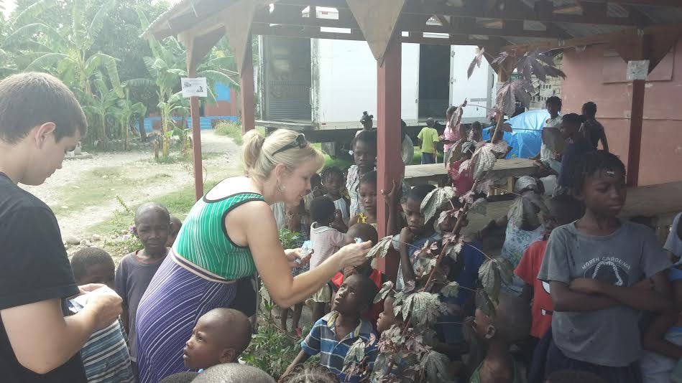

The people of Haiti are precious, but we were saddened by the amount of poverty we witnessed. The orphanage at Leogone stood in stark contrast to Sue’s place. One hundred children were malnourished and under nurtured. We took food and supplies but we were suspect of the Director. Christianville tries to intervene, but they are afraid most of what they give doesn’t get to the children. The most painful thing in the world was to leave those children. We almost kidnapped a few of the really sick ones. We wanted to do so much more.
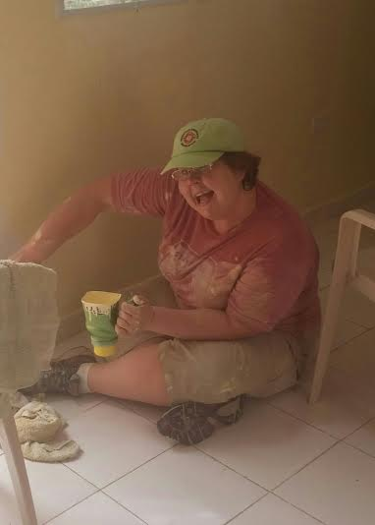
Jen, Jarrett and Lindy painted Sue’s Place for many days. Jen always displays a
great atitude!

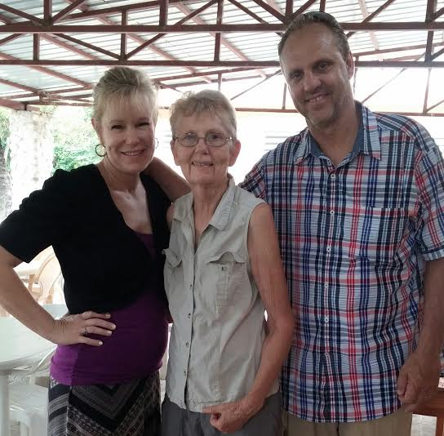
Both Bryan and Lindy have said they want to be like this beautiful woman when they grow up—Miss Sue.

God did incredible things in our hearts that week and we would like to go again. It was a favorite week in our lives because we could serve with abandon instead of being encumbered by everyday life (no making meals for Lindy!). One of the Christianville schools is in dire need of a new roof and there is so much other work to do. Think about joining us in the future. Christianville is primitive in many ways, but wonderful and a safe little slice of heaven in a dark place. Again, we are beyond grateful for your support. Thank you for partnering with us.

We love you, Bryan, Lindy, Jen & Jarrett

Great memories of Haiti:
- Racing through the marketplace of Leogone with Pastor Raymond (Immanuel Seminary and the most stellar guy) who negotiated the buying of food for the Leogone children. Lindy telling Raymond that he had to buy vegetables and not just rice and beans. Raymond saying, “But we’re trying to feed 100 kids!”
- Sitting in Miss Sue’s common room with twenty kids scattered around, watching Mulan on a laptop. Our laps always had a kid on it.
- Chunky 3 year old twin girls who wore their shoes to bed every night because they were so proud of them.
- Seeing and holding a healthy, thriving Baby Rose after Sue showed us the picture of when she received Rose—4 months old and less than 5 pounds
- The ribbon cutting ceremony we threw for Sue the last night we were there. Balloons, children singing, cookies and sentiments for Sue. Tucking the girls in that night and witnessing one five year old who had half her cookie wrapped up and kept close.

